Task 2 – Test Log
Description of test | Test data to be used  (if required) | Expected outcome | Actual outcome | Comments and intended actions
Function tests |  | Running the function should enter the code into the function code | 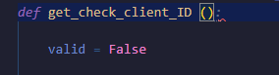  Get_check_client_ID does not run as there is no colon defining it as a function. | Add a colon to define the function
Check ID function test |  | It should run the function without error
Make sure the main function is ran |  | The code should execute what is in the main function to allow the code to run | 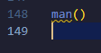  The code does not run as the main function is not called, in the code it Is misspelt as “man()” | Correct the spelling and re run the test
Running main() |  | The code should execute | The code executes properly
Savings plan code runs without issues | James – name  Id – 1234567890  Amount – 1000  Option 1 | It runs and accepts the data | 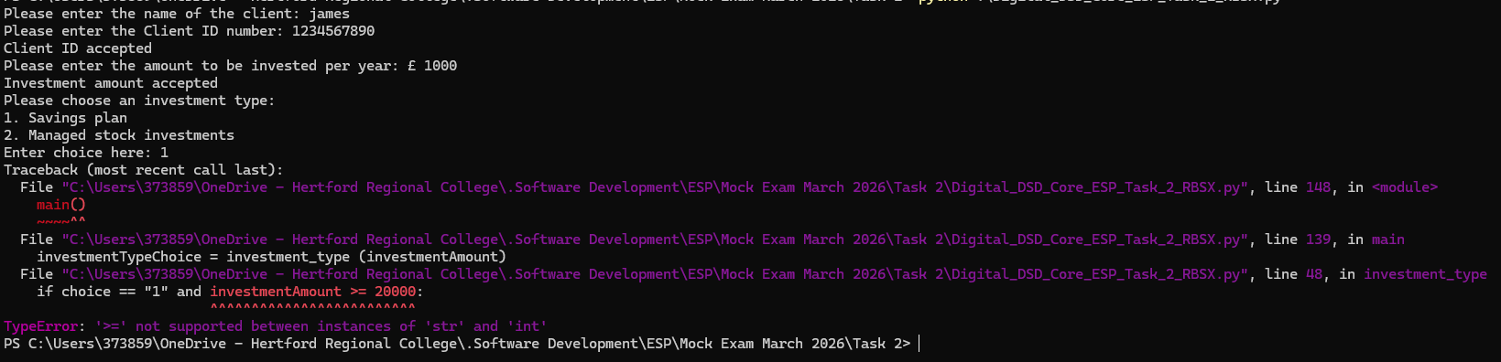  It breaks, Because the investment is taken as a float, and >= only takes integers and strings.  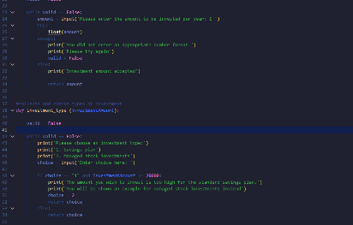 | Make amount an integer before returning it  “amount = int(amount)”
Savings plan code runs no issues | James – name  Id – 1234567890  Amount – 1000  Option 1 | The code runs and does not error | The code now fully runs and does not crash
Client id needs to be 10 char long | James  1 and 12345678901 | Should make user retry | The code accepted anything below 10 | Change the code from  ``` if len(clientID) > 10:```  To  ``` if len(clientID) != 10:  ```
Retest client id being 10 | James  1 and 12345678901 | Should not accept  Makes user re enter a valid 10 char ID | It refuses 1 and 12345678901 only accepts length of 10
Readability | James  1234567890  1000  Option 1 | The output should be easy to read and understand. | It is hard to read, and could be confusing  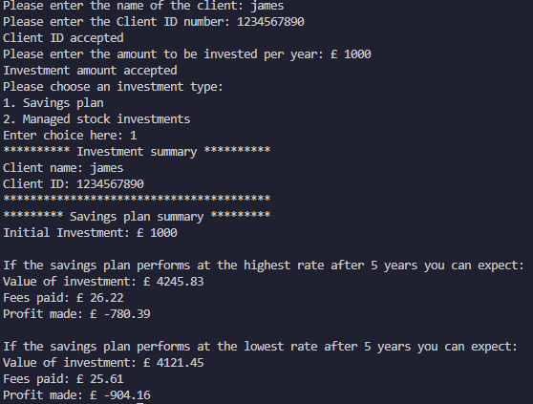 | Add “\n” and a clear_screen function to clear the terminal output  ``` def clear_screen():  import os  os.system('cls' if os.name == 'nt' else 'clear') ```  Example of the function
System test | James  1234567890  10,000  Option 1 | Should allow the user in,  Run their amount and show how much they earn / loose | Works Spits out summary seems correct.  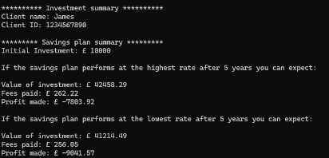
System test 2 | Dave  0987654321  10,000  Option 2 | Should run, allow the user to fully complete the script | Works, user is fully allowed through  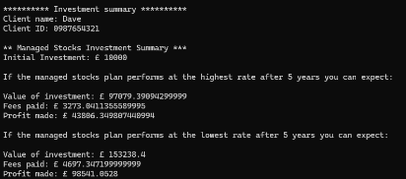
Boundry Test 1 | James  11 | Should stop the user getting in as ID is only 2 char long | 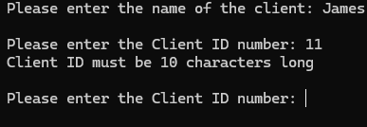  Stops users getting in
Boundray test 2 | Dave  12345678901 | Should stop user getting in as ID is 11 char long | 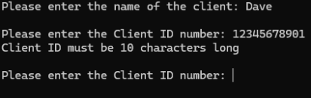  Stops user getting in
Boundry Test 3 | James  1234567890  30,000  Option 1 | Should switch user over to Managed stocks profile due to amount too high for savings. | 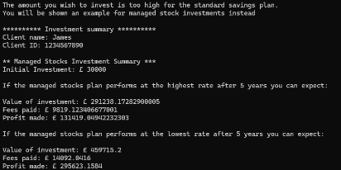  Switches over to the MSI
Savings math’s | James  1234567890  10,000  Option 1 | Should show the correct amount |  | Idk I could not do the math’s  T_T
MSI Math’s | James  1234567890  10,000  Option 2 | Should show the correct amounts |  | Again Idk, seems way better than Savings but I cannot do that math’s right now  T_T

Copyright and Acknowledgements
‘T-LEVELS’ is a registered trademark of the Department for Education.
‘T Level’ is a registered trademark of the Institute for Apprenticeships and Technical Education.
The T Level Technical Qualification is a qualification approved and managed by the Institute for Apprenticeships and Technical Education.
‘Institute for Apprenticeships & Technical Education’ and logo are registered trademarks of the Institute for Apprenticeships and Technical Education.
Pearson Education Limited is authorised by the Institute for Apprenticeships and Technical Education to develop and deliver this Technical Qualification.
Pearson and logo are registered trademarks of Pearson.
Copyright in this document belongs to, and is used under licence from, the Institute for Apprenticeships and Technical Education, © 2025

